Mary Viola (Sheets) Smith
October 18, 1874 – April 27, 1915

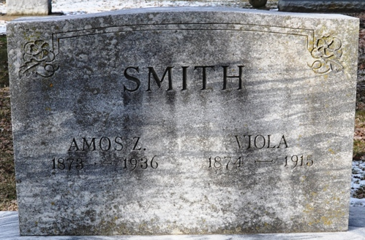
Photo by Deb Curry

Van Wert County, Ohio Birth Records Book 1, p. 186, #499
SHEETS, Mary Viola
Born: 18 Oct. 1874; Harrison Twp, Van Wert County, Ohio White/female
Parents: Josiah Sheets/Ruth Ann Howell
Residence: Harrison Twp
Reported by: Josiah Sheets

**
Indiana, U.S., Death Certificates, 1899-2017
Name Mary Viola Smith
[Mary Viola Sheets]
Gender Female
Race White
Marital Status Married
Age 40
Birth Date 18 Oct 1874
Birth Place Van Wert Co., Ohio
Death Date 27 Apr 1915
Death Place Washington, Adams, Indiana, USA
Death Registration Date 1910-1919
Father Josiah Sheets
Mother Ruth Ann Howell
Spouse Amos Z. Smith
Informant Amos Z. Smith; Decatur, Indiana
Burial April 29, 1915; Decatur Cemetery

