Mary (Beitler) Smith
January 1, 1896 – December 28, 1987

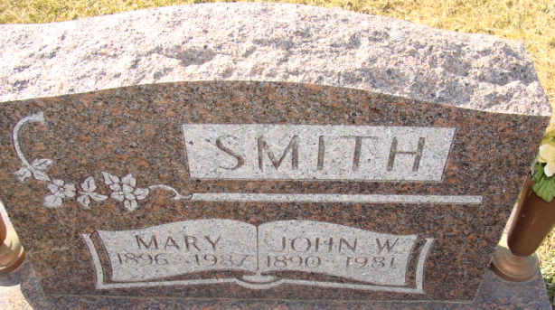
Photo by Alicia Kneuss

Mary Smith
in the Indiana, U.S., Death Certificates, 1899-2017
Name Mary Smith
[Mary Beitler]
Gender Female
Race White
Marital Status Widowed
Age 91
Birth Date 1 Jan 1896
Birth Place Indiana
Death Date 28 Dec 1987
Death Place Decatur, Adams, Indiana, USA
Death Registration Date 1987
Father Lawrence Beitler
Mother Anna Baumgartner
Informant Bette Wulliman; daughter; Berne, Indiana
Burial December 31, 1987; Decatur Cemetery; Decatur, Indiana

