Mary Berniece (Knittle) Smith
May 5, 1913 – July 6, 1997

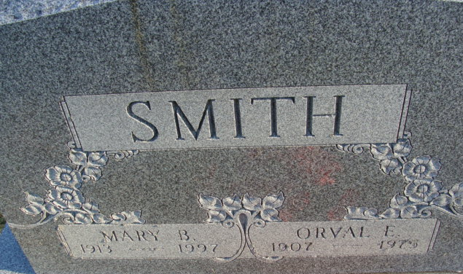
Photo by Alicia Kneuss

Mary Berniece “Peggy” Smith, 84, died Sunday at Convoy Care Center. Born in Adams County, she was a waitress and cook at State Gardens, Middlebury. She and her husband owned and operated Smitty's Place on Randall Lake in Coldwater, Mich., for more than 20 years.
Surviving are a son, Edward J. of Bronson, Mich.; three daughters, Alice Endsley of Convoy, Nancy Merling of Mount Clemens, Mich., and Elaine Braunsberger of Hesperia, Calif.; a brother, Chalmer Knittle of Decatur; four sisters, Mildred Manley and Ruth Nicodemus, both of Decatur, Betty Fisher of Fort Wayne, and Blondie Bricker of Portland; 21 grandchildren; eight great-grandchildren; and four great-great-grandchildren. Her husband, Orval E., died in 1975.
Services at 11 a.m. EDT (10 a.m. Fort Wayne time) Wednesday at Cowan & Son Funeral Home, Van Wert, with calling from 2 to 4 and 6 to 9 p.m. EDT Tuesday. Burial in Decatur Cemetery, Ind.
Memorials to American Cancer Society.

Journal Gazette, Allen County, Indiana
Monday, July 7, 1997
**
SSDI: Mary B. Smith
Last Residence: 45832 Convoy, Van Wert, Ohio
Born: 5 May 1913
Died: 6 Jul 1997
Issued: Ohio (Before 1951)

