Martha D. (Cline) Smith
October 13, 1871 – January 19, 1954

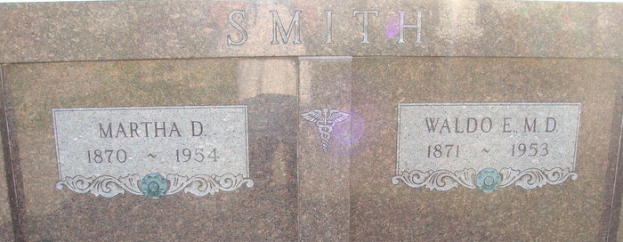
Photo by Alicia Kneuss

Mrs. W. E. Smith Is Taken By Death
Widow Of Decatur Physician Is Dead
Funeral services will be held Friday for Mrs. Martha D. Smith, 83, widow of Dr. W. E. Smith, who died Tuesday afternoon at the Adams County Memorial Hospital, where she had been a patient for three and one-half weeks.
She was born in Union Township Oct. 13, 1871, a daughter of George B. and Lavinia Luckey-Cline, one of the county's pioneer families. Her birthplace, three and one-half miles (sic) of Decatur, was part of the old Luckey homestead.
She was graduated from Ohio Northern University of Columbus, O., and was married to Dr. W. E. Smith Dec. 25, 1893. Her husband, a prominent Decatur physician, died April 9 of last year.
Mrs. Smith was a member of the First Presbyterian Church, the Woman's Club, Garden Club, Historical Club and the Adams County Medical Auxiliary.
Surviving are two daughters, Mrs. Lucile Eicher of Rocky River, O., and Mrs. Genevieve Santini of Tenafly, N. J.; one son, Dr. Lowell C. Smith of Lafayette; six grandchildren and 12 great-grandchildren. One brother preceded her in death, and a grandson, Waldo Edison Eicher, was killed during World War II.
Services will be conducted at 1:30 p.m. Friday at the Zwick funeral home, the Rev. Ray J. Walther officiating. Entombment will be in the mausoleum at the Decatur Cemetery. Friends may call at the funeral home after 7 o'clock this evening until time of the services.

Decatur Daily Democrat, Adams County, Indiana
Wednesday, January 20, 1954

