Marshia K. (Ohler) Smith
August 26, 1912 – October 11, 2004

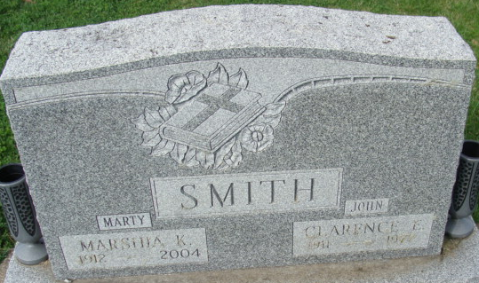
Photo by Alicia Kneuss

Marshia K. Smith 92 of Decatur, IN passed away at 4:25 am [Monday, 10/11/2004] at Woodcrest Nursing Center. She was the daughter of William F. and Daisy Mae (Lee) Ohler, born August 26, 1912 in Adams Co., IN. She married Clarence Smith on Oct. 25, 1930 he passed away Nov., 1977.
Marshia was the mother of a son Robert E. Smith of Arlington, TX and 2 daughters Mrs. Janet Manns of Arlington, TX and Mrs. James (Judith) Lawrence of Ft. Wayne, IN. She had 12 grandchildren, 26 great grandchildren and 5 great-great grandchildren.
She was a member of St. Mark's United Methodist Church and it's Ladies Circle. She was also a member of the Decatur Women's club and was very active in the Democratic Party Local and State.
Funeral services will be on Thursday, Oct. 14 at 10:00 am at the Woodcrest Auditorium with visitation from 9-10 prior to service. Visitation will be on Wednesday, Oct. 13 from 3-7 pm at Haggard and Sefton Funeral Home. Officiating will be Rev. Jeff Taylor and burial will be at Decatur Cemetery.
Memorials are to St. Mark's United Methodist Church or Gideon's.

Haggard & Sefton Funeral Home, Adams County, Indiana
October 12, 2004

