Margaret Louise (Yocum) Smith
August 7, 1914 – September 23, 2008

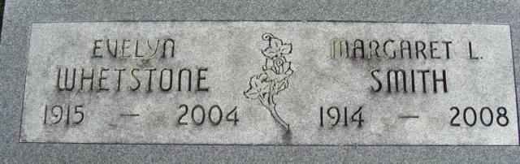
Photo by Alicia Kneuss

Margaret L. Smith, 94 of Rockford, Ohio formerly of Decatur died on Tuesday, September 23, 2008 at Adams Memorial Hospital. Margaret was born on August 7, 1914 in Adams County, Indiana to the late Henry L. Yocum and Ada Drummond.
Margaret is survived by two daughters Sharon L. Thatcher of Rockford, Ohio and Mrs. Gene (Norma L.) Kunda of Wheaton, Illinois, she has six grandchildren and 11 great grandchildren. Preceded Margaret in death is two brothers Doyle & John Yocum and two sisters Doris Wittung and Evelyn Whetstone.
Margaret worked for Westinghouse Corporation in Lima, Ohio.
Calling hours are from 6-8 pm Friday, September 26, 2008 at Haggard & Sefton Funeral Home. Funeral service will be at 11:00 am Saturday, September 27, 2008 also at the funeral home. Burial will be in Decatur Cemetery and memorials are to Gideons International.

Haggard & Sefton Funeral Home, Adams County, Indiana
Wednesday, September 24, 2008

