Margaret Eleanor (Cowan) Smith
July 17, 1848 – May 31, 1919

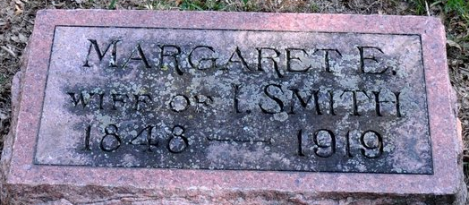
Photo by Deb Curry

ILL A LONG TIME - Death Came Saturday to Margaret Smith, Widow of Isaac Smith - SEVENTY YEARS OLD - Funeral Tuesday Afternoon from the Calvary Church -- Burial Here
Margaret Eleanor Cowan Smith, widow of Isaac Smith, died Saturday afternoon at three o'clock at her home six miles east of Decatur, in St. Mary’s Township. She had been ill for some time following a paralytic stroke, but death was due directly to chronic interstitial nephritis.
Mrs. Smith was seventy years, eleven months and fourteen days of age. She was born July 17, 1848, and was a daughter of Mr. and Mrs. Israel Cowan.
Her husband died January 26, 1915, and a son is also deceased. She is survived by two daughters, Miss Jennie Smith at home; and Mrs. Delbert Walters. She also has one sister, who lives in the west; also a number of half-brothers and sisters.
The funeral will be Tuesday afternoon at two o'clock from the Calvary church, with the Rev. Baumgartner, Evangelical minister, officiating. Burial will be in the Decatur Cemetery.

Decatur Daily Democrat, Adams County, Indiana
Monday, June 2, 1919
**
Indiana, U.S., Death Certificates, 1899-2017
Name Margret Eleanor Cowan Smith
[Margret Eleanor Cowan]
Gender Female
Race White
Marital Status Widowed
Age 70
Birth Date 17 Jul 1848
Birth Place St Mary Twp., Adams Co Indiana
Death Date 31 May 1919
Death Place St. Mary's, Adams, Indiana, USA
Death Registration Date 1919
Father Israel Cowan
Mother Eliza Allen
Spouse Isaac Smith
Informant Mrs. Lula Walters; Decatur, Indiana
Burial June 3, 1919; Decatur Cemetery

**
Zwick Funeral Home Records 1918-1922
Name of Deceased Mrs. Margret Eleanor Cowan Smith
Casket No. #0154 1/4 DS oval T of aurora; Size 6' 3"; $350.00
Metal Vault Style 2 Clark; $80.00
Burial Robe Dress; $20.00; Slippers #6; $3.00
Flowers Basket for family $7.00; Spray for calvery SS $3.00
Date of Funeral June 3, 1919; 2:00 p.m.
Date of Death May 31, 1919
Place of Death St. Mary's Township, Adams County, Indiana
Place of Funeral Calvery E V Church
Clergyman Rev. Baumgartner
Date of Burial June 03, 1919
Where Interred Decatur Cemetery
Born July 17, 1848
Age 70 years, 11 months, 14 days
Color White
Occupation Housekeeper
Status Widow
Birthplace St. Mary's Township, Adams County, Indiana
Last Place of Residence St. Mary's Township, Adams County, Indiana
How Long Resident of This State Life
Husband's/Wife's Name Isaac Smith
Father's Name Israel Cowan; Country of Birth Pennsylvania
Mother's Name Eliza Allen; Country of Birth Ohio
Physician Dr. J. Kirk, Daisy, Ohio
Cause of Death Chronic Intestinal Nephritis
Ordered By Miss Jennie Smith
Charge To Mrs. Margret E. Smith Estate
When Rendered June 03, 1919
Received on Account June 2, 1919; by cash from J. W. Teeple; $5.00
Received on Account June 7, 1919; by cash S. School; $3.00
Received on Account August 13, 1919; by cash ?; $75.00
Received on Account January 29, 1920; by cash per W. H. Teeple, ex.; $190.00
Received on Account July 8, 1920; by ck; WHT; $75.00 (PAID $468.00)

