Margaret Ellen “Peggy” Smith
January 9, 1949 – March 2, 1965

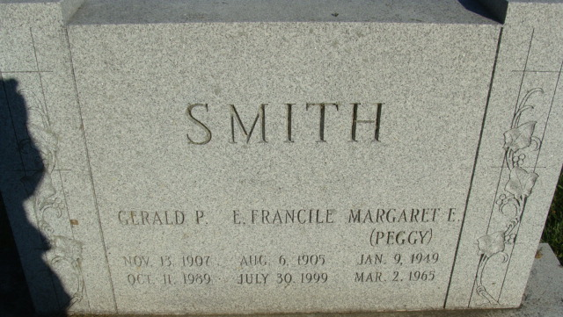
Photo by Alicia Kneuss

Margaret Ellen Smith
in the Indiana, U.S., Death Certificates, 1899-2017

Name Margaret Ellen Smith
Gender Female
Race Caucasian (White)
Marital Status Never Married (Single)
Age 16
Birth Date 9 Jan 1949
Birth Place Indiana
Death Date 2 Mar 1965
Death Place Decatur, Adams, Indiana, USA
Death Registration Date 1965
Father Gerald P Smith
Mother Francile Lower
Informant Gerald Smith; father; Decatur, Indiana
Burial March 5, 1965; Decatur Cemetery; Decatur, Indiana

