Lydia (Schraluka) Smith
January 13, 1874 – July 6, 1918

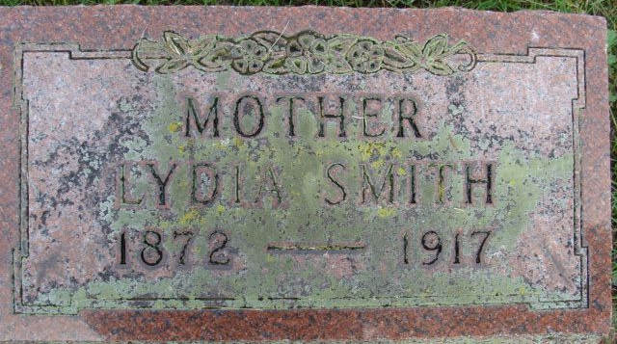
Photo by Alicia Kneuss

TO HER REWARD - Mrs. Elmer Smith Answered the Last Summons
AT AN EARLY HOUR - Died This Morning
Was Operated Upon Thursday

Lydia Schraluka Smith, wife of Elmer Smith of North Fourth Street, died this morning at 2:39 o'clock at the Lutheran Hospital, Fort Wayne, following an operation of Thursday for interna [sic] cancer. Mrs. Smith had been ailing for some time but she had not been bedfast except since the operation, and in fact her condition was not known by her many friends to be serious. She went to Fort Wayne last Wednesday where she entered the hospital. The operation revealed a most serious condition and she sank rapidly. Last evening she grew much worse and her brother and sisters and other near relatives were called to her bedside. Her husband remained with her, but the sisters and brother returned home on the 10 o'clock car.
Mrs. Smith was 43 years of age last January 13. She was born at Magley, being a daughter of William and Sophia Schraluka, a well known family of Preble Township. She was reared there and 23 years ago in October was united in marriage to Elmer Smith, since which time they have lived in this city for the greater part of that period.
A daughter, Hazel, is deceased, but four sons are living: Burton, Harold, Dale and Richard.
Mrs. Smith is the first one of a family of one boy and six girls to pass away. The sisters and brother are: Rachel Hawk of Montpelier; Mrs. John Cook, Cardwell, Mo.; Lizzie Schraluka, Sophia Smith and Amelia Diller, of this city; and William Schraluka of Decatur.
Mrs. Smith was a member of the Christian church. She was a lady of fine Christian character, a good wife and mother, and will be missed not only in the home, but in the entire community, and in all phases of church life, where she was very active. She was long a member of the Christian Ladies' Aid Society and one if its splendid workers, as well as of the Sunday School and of the Missionary Society.
The body was brought to the home in this city this morning.
Funeral services for Mrs. Smith will be held Tuesday afternoon at the Christian church, the hour to be announced later. The Rev. W. Paul Marsh will officiate.

Decatur Daily Democrat; Adams County, Indiana
Saturday, July 6, 1918

**
Indiana, U.S., Death Certificates, 1899-2017
Name Lyda Smith
[Lyda Shralukai]
Gender Female
Race White
Marital Status Married
Age 44
Birth Date 13 Jan 1874
Birth Place Indiana
Death Date 6 Jul 1918
Death Place Fort Wayne, Allen, Indiana, USA
Father Wm Shralukai
Mother Sophia Lindenau
Spouse Elmer Smith
Informant Elmer Smith; Decatur, Indiana
Burial July 8, 1918; Decatur Cemetery

