Luetta M. (Reffey) Smith
May 13, 1912 – September 28, 1981

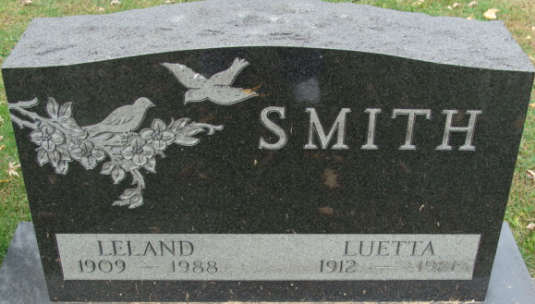
Photo by Alicia Kneuss

Luetta M Smith
in the Indiana, U.S., Death Certificates, 1899-2017
Name Luetta M Smith
[Luetta M Reffey]
Gender Female
Race White
Marital Status Married
Age 69
Birth Date 13 May 1912
Birth Place Indiana
Death Date 28 Sep 1981
Death Place Fort Wayne, Allen, Indiana, USA
Death Registration Date 1981
Father Leander Reffey
Mother Pearl Baker
Spouse Leland Smith
Informant Leland Smith; Fort Wayne, Indiana
Burial October 2, 1981; Decatur Cemetery; Decatur, Indiana

