Lois A. (Westhoff) Smith
August 20, 1915 – May 3, 2008

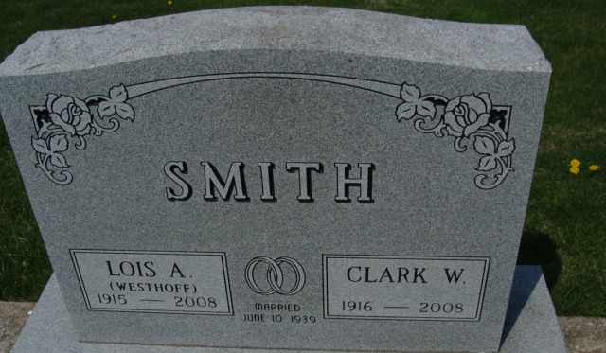
Photo by Alicia Kneuss

Lois A. Smith, 92, formerly of Decatur and Indian Harbor Beach, Florida, died Saturday in Wuesthoff Hospice Care Center at Rockledge, Florida.
She was born on August 20, 1915, in Allison Park, Pennsylvania, to Harry F. and Sarah A. Knapp Westhoff. She married Clark W. Smith on June 10, 1939; he survives.
She was a homemaker and a member of First Presbyterian Church.
Other survivors are a daughter, Mrs. Jerry (Deborah A.) McVicker of Indian Harbor Beach, and five grandchildren.
A daughter, six sisters, and two brothers are deceased.
Funeral services will be held at 3 p.m. Saturday in Haggard and Sefton Funeral Home, with burial in Decatur Cemetery. Visitation is 2-3 p.m. Saturday.
Preferred memorials are to the church.

Decatur Daily Democrat, Adams County, Indiana
Wednesday, May 7, 2008

