Lewis Lutz Smith
April 27, 1919 – May 20, 1984

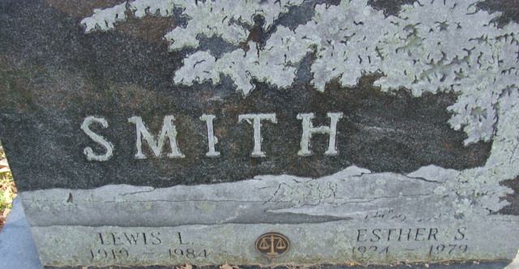
Photo by Alicia Kneuss

Lewis Lutz Smith
in the Indiana, U.S., Death Certificates, 1899-2017
Name Lewis Lutz Smith
Gender Male
Race White
Marital Status Widowed
Age 65
Birth Date 27 Apr 1919
Birth Place Indiana
Death Date 20 May 1984
Death Place Fort Wayne, Allen, Indiana, USA
Death Registration Date 1984
Father Fred R. Smith
Mother Jean B. Lutz
Informant Stephen L. Smith; son; Decatur, Indiana
Burial May 23, 1984; Decatur Cemetery; Decatur, Indiana

