Leon D. Smith
1920 - 1921

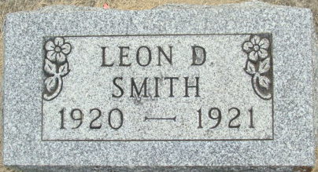
Photo by Alicia Kneuss

No further information found at this time

