Leo W. Smith
August 7, 1917 – August 1, 1989

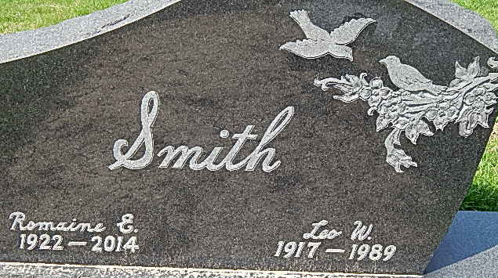
Photo by Alicia Kneuss

Leo W. Smith
in the U.S., Social Security Death Index, 1935-2014
Name: Leo W. Smith
Social Security Number: xxx
Birth Date: 7 Aug 1917
Issue Year: Before 1951
Issue State: Ohio
Death Date: 1 Aug 1989

