Leland Smith
July 20, 1909 – October 10, 1988

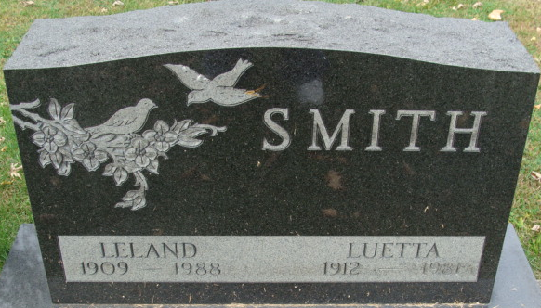
Photo by Alicia Kneuss

Leland Smith
in the Indiana, U.S., Death Certificates, 1899-2017
Name Leland Smith
Gender Male
Race White
Marital Status Married
Age 79
Birth Date 20 Jul 1909
Birth Place Cass Co Iowa
Death Date 10 Oct 1988
Death Place Fort Wayne, Allen, Indiana, USA
Death Registration Date 1988
Father Ira B Smith
Mother Nettie P Saxton
Spouse Eileen Casterline
Informant Eileen Smith; wife; Fort Wayne, Indiana
Burial October 15, 1988; Decatur Cemetery; Decatur, Indiana

