Lawrence R. Smith
May 26, 1914 – October 13, 2011

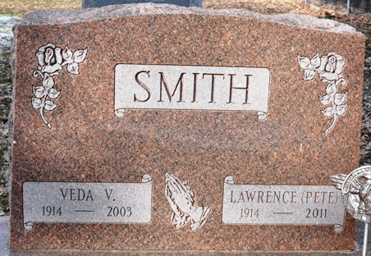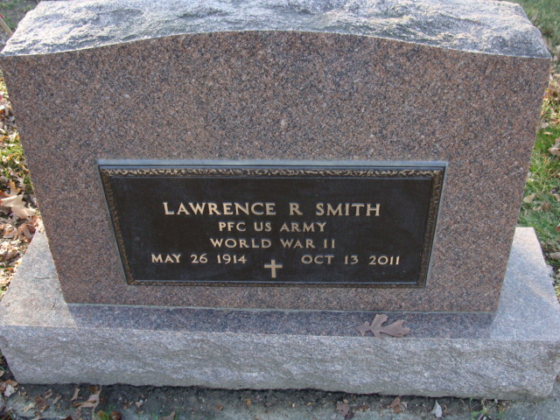
Photo by Alicia Kneuss

Lawrence R. “Pete” Smith, 97, of Decatur, IN passed away at 10:00 a.m. on Thursday, October 13, 2011 at Adams Memorial Hospital. He was born on May 26, 1914 in Decatur, Indiana to the late Daniel Ray and Grace (Zerkel) Smith. On May 30, 1936 he married Veda V. Smith. She preceded him in death on April 4, 2003.
Pete was a member of St. Mark’s United Methodist Church. He retired in 1978 from Prestress Services and also was a crane operator for Adams County Surveyors office.
He served in World War II in the Army. Pete was also a member of the American Legion Post #43.
He is survived by 4 daughters Lorna (Bob) Molden of Spring Hill, FL, Betty (Barney) Brooks of Estero, FL, Donna (Dan) Lasseter of Peachtree City, GA, and Dorothy (Don) Poling of Decatur, IN; 6 grandchildren, 10 great grandchildren and 2 great-great grandchildren. Preceded him in death was a brother John Smith, a sister Ruth Merriman and a grandson Rodney Hildebrand.
Visitation will be from 4:00 - 7:00 p.m. on Tuesday, October 18, 2011 with a Funeral Service to take place at 7:00 p.m. at Haggard-Sefton & Hirschy Funeral Home with Military Graveside rites by American Legion Post #43 Color Guard. Pastor Michael Heinbaugh will be officiating and burial will be in Decatur Cemetery.
Memorials are to St. Mark’s United Methodist Church or Family Life Care-Hospice.

Haggard-Sefton Funeral Home, Adams County, Indiana
October 14, 2011

