Laura Belle (Magner) Smith
June 16, 1868 – November 1, 1944

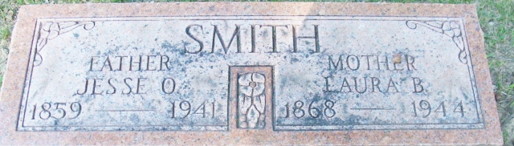
Photo by Alicia Kneuss

Laura Belle Smith
in the Indiana, U.S., Death Certificates, 1899-2017
Name Laura Belle Smith
[Laura Belle Magner]
Gender Female
Race White
Marital Status Widowed
Age 76
Birth Date 16 Jun 1868
Birth Place Indiana Allen County
Death Date 1 Nov 1944
Death Place Fort Wayne, Allen, Indiana, USA
Death Registration Date 1944
Father Josuha Magner
Mother Mary Wire
Spouse Jesse O Smith
Informant Mrs. Maria Lahow?; Fort Wayne, Indiana
Burial November 4, 1944; Maple Wood Cemetery; Decatur, Indiana

