Landon David Smith
August 22, 1888 – June 23, 1938

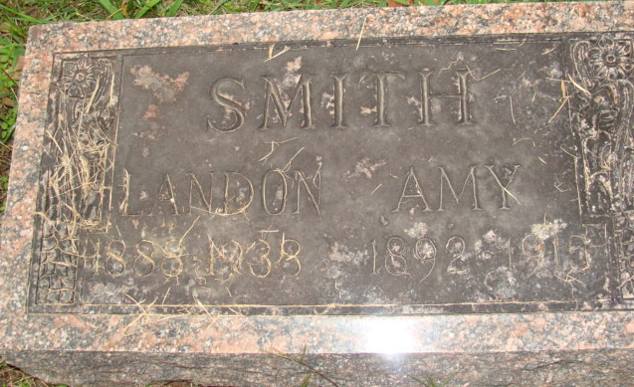
Photo by Alicia Kneuss

Landon D Smith
in the New York, New York, U.S., Index to Death Certificates, 1862-1948
Name Landon D Smith
Gender Male; Race White
Marital Status Married
Age 49
Birth Date 22 Aug 1888
Birth Place Indiana
Residence Street Address 107-39 114 Th St, New York
Years in US 13 Years
Death Date 23 Jun 1938
Death Street Address 107-39 114Th Str
Death Place New York City, Queens, New York, USA
Cause of Death Coronary Thrombosis, Hypertensive Heart Disease
Burial Date 27 Jun 1938
Burial Place Maple Grove Cemetery
Occupation Asst Supt
Father Robert Smith b. USA
Mother unknown b. USA
Spouse Arlene Smith
Executor Arlene Smith; Executor Relationship Wife

**
Landon David Smith from tree Ancestry of Roger Davis
Birth 24 Aug 1888 Adams, Indiana, USA
Marriage 1919
Residence 1920 Grand Rapids, Kent, Michigan, USA
Death 23 Jun 1938 New York City, New York, USA
Father Robert Edison Smith (1844-1912)
Mother Idellia Teresa Miller (1844-1908)
Spouse Oreene Renaker (1894-1975)

