Juanita Smith
1919 -

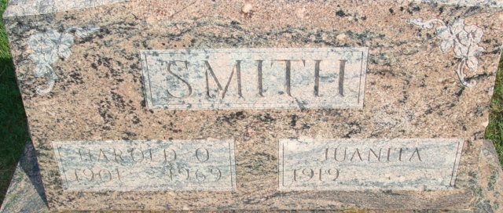
Photo by Alicia Kneuss

