Joseph Louis Smith
September 12, 1857 – August 26, 1948

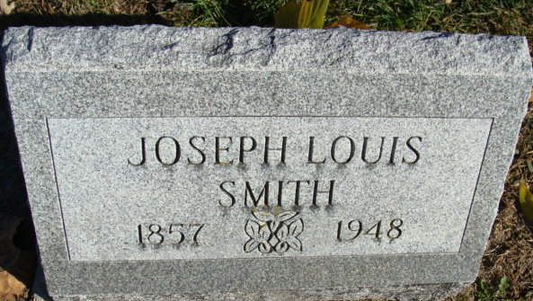
Photo by Alicia Kneuss

Joseph Louia Smith
in the Indiana, U.S., Death Certificates, 1899-2017
Name Joseph Louis Smith
Gender Male
Race White
Marital Status Widowed
Age 91
Birth Date 12 Sep 1857
Birth Place Decatur Avilla Indiana
Death Date 26 Aug 1948
Death Place Avilla, Noble, Indiana, USA
Death Registration Date 1948
Father Augustine Smith
Mother Nancy Ann Smith
Informant Zach Smith; Bryan, Ohio
Burial August 28, 1948; Decatur Cemetery; Decatur, Indiana

