John W. Smith
June 6, 1890 – January 28, 1981

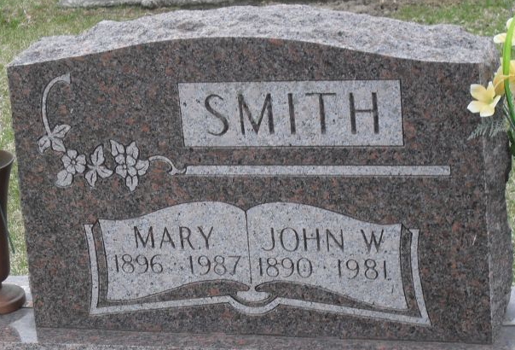
Photo by Stephen & Andrea Brangan

John W. Smith
in the Indiana, U.S., Death Certificates, 1899-2017
Name John W. Smith
Gender Male
Race White
Marital Status Married
Age 90
Birth Date 6 Jun 1890
Birth Place Ohio
Death Date 28 Jan 1981
Death Place Decatur, Adams, Indiana, USA
Death Registration Date 1981
Father John W. Smith
Mother Nettie Hart Smith
Spouse Mary Beitler Graber
Informant David Smith; Decatur, Indiana
Burial January 31, 1981; Decatur Cemetery; Decatur, Indiana

