John McClelland Smith
1859 – January 7, 1941

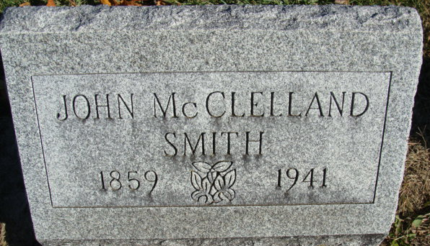
Photo by Alicia Kneuss

Ohio, Deaths, 1908-1953
Name John Smith
Sex Male
Birth February ??, 1859
Age 81 years, 11 months, 25 days
Father's Name Augustus P. Smith
Father's Sex Male
Mother's Name Nancie Smith
Mother's Sex Female
Spouse's Name Belle Gessinger
Spouse's Sex Female
Event Type Death
Event Date 07 Jan 1941
Event Place Williams, Ohio
Event Place (Original) Williams, Ohio
Informant Zach Smith; Bryan, Ohio
Burial January 9, 1941; Decatur, Indiana
Source Details fn 7414
**
John McClelland Smith from tree Case Family Tree
Birth Feb 1859 Decatur, Adams, Indiana, USA
Marriage 6 Jul 1900 Allen, Indiana, USA
Residence 1910 Pulaski, Williams, Ohio, USA
Death 7 Jan 1941 Bryan, Williams, Ohio, USA
Father Augustus P Smith (1831-1889)
Mother Nancy Ann Smith (1833-1895)
Spouse Cora Belle Gessinger (1872-1948)

