John Edward Smith
May 17, 1833 – August 9, 1910

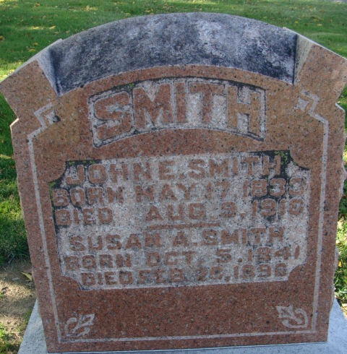
Photo by Alicia Kneuss

Decatur Pioneer is Dead
John E. Smith, Former Coroner of Adams County, Dead
(Special to the Journal-Gazette)
Decatur, Ind., Aug. 10 – John Edward Smith, aged seventy-seven; who since 1882 has been a resident of the city, is dead at his home on Eighth Street, after a five weeks illness of catarrhal affection of the stomach and bowels.
He was a son of Robert and Maria Smith, born in Lancashire, England in 1833, and coming to this country, settling in Ohio.
He was married to Susannah Andrews, whose death occurred in 1896.
The only son, Arthur, died at the age of six years.
The deceased was a harness maker, retiring several years ago. He was keeper of the Adams County Jail in the seventies and also served as coroner.
J. H. Smith of this city, and Mrs. A. D. Clarkson, of Piqua, Ohio, is his surviving brother and sister.
The funeral will be held tomorrow afternoon at 2 o'clock from the home. The Rev. Imler officiating.

Journal-Gazette, Allen County, Indiana
August 11, 1910

**
Indiana, U.S., Death Certificates, 1899-2017
Name John E. Smith
Gender Male
Race White
Marital Status Widower
Age 77
Birth Date 17 May 1833
Birth Place England
Death Date 9 Aug 1910
Death Place Decatur, Adams, Indiana, USA
Death Registration Date 1910
Father Robert Smith
Mother Maria Drake
Informant David E. Smith; Decatur, Indiana
Burial August 11, 1910; Maplewood Cemetery

