John Adam Smith
June 25, 1850 – November 5, 1932

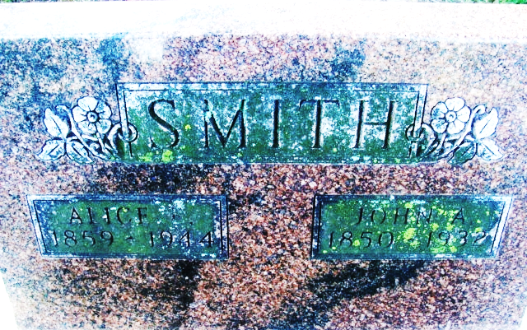
Photo by Alicia Kneuss

John Adam Smith
in the Indiana, U.S., Death Certificates, 1899-2017
Name John Adam Smith
Gender Male
Race White
Marital Status Married
Age 82
Birth Date 25 Jun 1850
Birth Place Indiana
Death Date 5 Nov 1932
Death Place Decatur, Adams, Indiana, USA
Death Registration Date 1932
Father John Smith
Mother Sarah Miller
Spouse Alice
Informant Alice Smith; Decatur, Indiana
Burial November 7, 1932; Decatur Cemetery

