Jesse O. Smith
January 8, 1859 – December 21, 1941

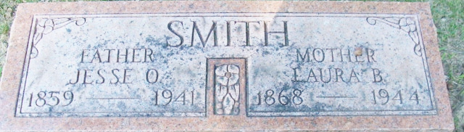
Photo by Alicia Kneuss

Jesse O Smith
in the Indiana, U.S., Death Certificates, 1899-2017
Name Jesse O Smith
Gender Male
Race White
Marital Status Married
Age 82
Birth Date 8 Jan 1859
Birth Place Adams County, Indiana
Death Date 21 Dec 1941
Death Place Fort Wayne, Allen, Indiana, USA
Death Registration Date 1941
Father Elias B Smith
Mother Kathryn Williams
Spouse Laura
Informant Alva Buffenbarger; Decatur, Indiana
Burial December 21, 1941; Decatur Cemetery

