Jennie M. (Hammell) Smith
1877 - 1945

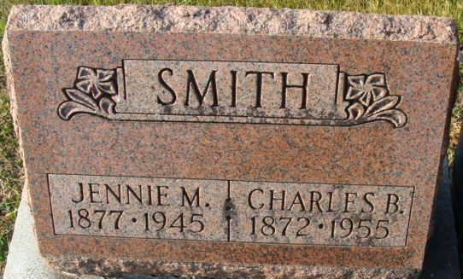
Photo by Alicia Kneuss

Jennie M Hammell from tree Gresley Family Tree
Birth 1877 Indiana, USA
Marriage 11 May 1901 Moline, Allegan, Michigan, USA
Residence 1940 Detroit, Wayne, Michigan, USA
Death 1945 Decatur, Adams, Indiana, USA
Father Cyrus Hammell (1841-1917)
Mother Sarah (Sadie) Baker (1856-1933)
Spouse Charles Brusman Smith (1872-1955)

