Jean B. (Lutz) Smith
April 18, 1889 – December 4, 1985

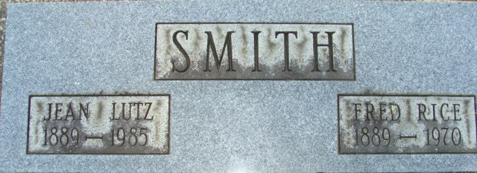
Photo by Alicia Kneuss

Jean B Smith
in the Indiana, U.S., Death Certificates, 1899-2017
Name Jean B Smith
[Jean B Lutz]
Gender Female
Race White
Marital Status Widowed
Age 96
Birth Date 18 Apr 1889
Birth Place Indiana
Death Date 4 Dec 1985
Death Place Fort Wayne, Allen, Indiana, USA
Death Registration Date 1985
Father Clark J Lutz
Mother Anna M Lewis
Informant Clark W. Smith; Decatur, Indiana
Burial December 6, 1985; Decatur Cemetery; Decatur, Indiana

