Jane (Shackley) Smith
March 4, 1880 – January 16, 1947

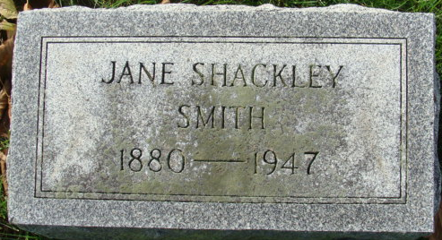
Photo by Alicia Kneuss

Jane Shackley Smith
in the Indiana, U.S., Death Certificates, 1899-2017
Name Jane Shackley Smith
[Jane Shackley]
Gender Female
Race White
Marital Status Widowed
Age 66
Birth Date 4 Mar 1880
Death Date 16 Jan 1947
Death Place Fort Wayne, Allen, Indiana, USA
Death Registration Date 1947
Father Howard W Shackley
Mother Samantha Kern
Spouse Bert R Smith
Informant Mrs. Wm. Burgard; Fort Wayne, Indiana
Burial January 18, 1947; Decatur Cemetery; Decatur, Indiana

