James R. Smith
January 6, 1827 – September 20, 1906

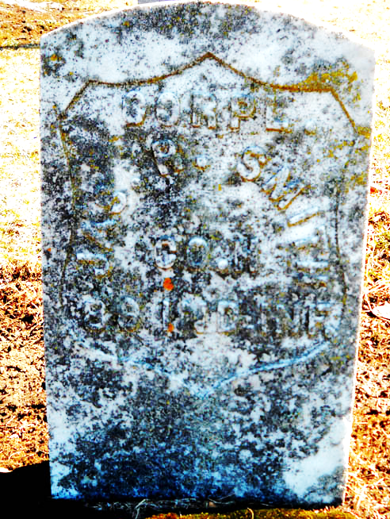
Photo by Drbuck

James R. Smith, one of the pioneers of this city and one of the best known men in Adams Co. died last evening, at 9:00 o'clock, at his home in the west part of the city after an illness dating back several months, death resulting from old age and a complication of diseases. He was 80 years of age and during most of that time made his home in this city.
He was an ardent Democrat, and during his life always took an active part. He was nominated, on the Democratic ticket, on several occasions for JP and during his term in this capacity always did his duty as he thought best and rendered his decisions according to law and evidence. He was an impartial judge, and all who came before him were afforded justice in the true light. Several different times he was nominated on the Democratic ticket for assessor, and in this capacity he did his duty as thoroughly as any man could.
He served in the Civil War for three years, enlisting 9th Aug 1862 at Decatur, discharged 8 Aug 1865 at Indianapolis. He was a reliable and trustworthy man and did his duty well, and when the war ended was given an honorable discharge by the government.
The funeral services will be held Sat afternoon at 2 p.m. at the M E Church, Rev J.C. White officiating. Internment in the Decatur Cemetery.

Decatur Democrat, Adams County, Indiana
A weekly newspaper
Thursday, September 27, 1906
**
Indiana, Death Certificates, 1899-2011
Name: James R Smith
Gender: Male
Race: White
Age: 79 years, 8 months, 16 days
Marital status: Widowed
Birth Date: 6 Jan
[abt 1827]
Birth Place: Ohio
Death Date: 20 Sep 1906
Death Place: Decatur, Adams , Indiana, USA
Father: Joseph R Smith
Mother: Lizzie Reeves
Spouse: Lida A
Informant: James O. Ball; Decatur, Ind.
Burial: Sept. 22, 1906; Decatur Cem.

