James Huber Smith
February 8, 1912 – February 14, 1913

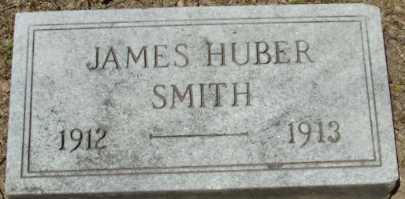
Photo by Alicia Kneuss

The funeral services for James H., year-old son of Mr. and Mrs. David E. Smith, who died Friday afternoon, will be held Sunday afternoon at 2:30 from the home. Rev. R. I. Semaus will officiate. Interment will be made at the Decatur Cemetery.

Decatur Daily Democrat; Adams County, Indiana
Saturday, February 15, 1913
**
Indiana, U.S., Death Certificates, 1899-2017
Name James Huber Smith
Gender Male
Race White
Age 1
Birth Date 8 Feb 1912
Birth Place Adams County
Death Date 14 Feb 1913
Death Place Decatur, Adams, Indiana, USA
Death Registration Date 1913
Father David E. Smith
Mother Ester Hale
Informant David Smith; Decatur, Indiana
Burial February 16, 1913; Decatur Cemetery

