James G. Smith
July 16, 1910 – October 5, 1986

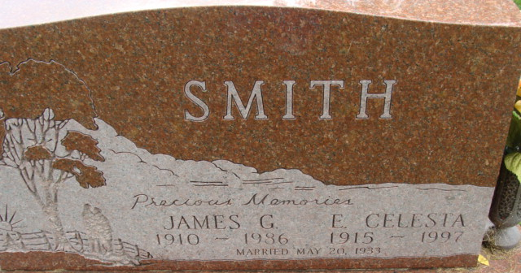
Photo by Alicia Kneuss

James G Smith
in the Indiana, U.S., Death Certificates, 1899-2017
Name James G Smith
Gender Male
Race White
Marital Status Married
Age 76
Birth Date 16 Jul 1910
Birth Place Indiana
Death Date 5 Oct 1986
Death Place Fort Wayne, Allen, Indiana, USA
Death Registration Date 1986
Father William G Smith
Mother Nora Dishong
Spouse Celesta
Informant Celesta Smith; wife; Decatur, Indiana
Burial October 7, 1986; Decatur Cemetery; Decatur, Indiana

