James G. Smith
May 2, 1866 – April 17, 1948

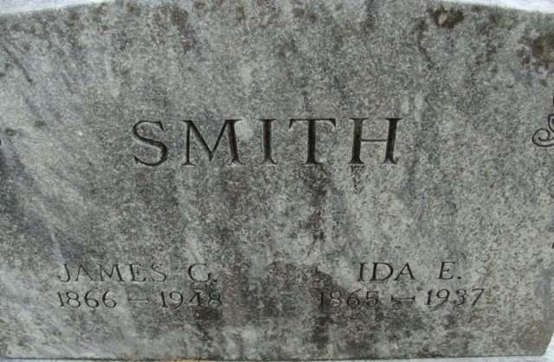
Photo by Alicia Kneuss

James J Smith
in the Indiana, U.S., Death Certificates, 1899-2017
Name James J Smith
Gender Male
Race White
Marital Status Widowed
Age 81
Birth Date 2 May 1866
Birth Place Decatur, Indiana
Death Date 17 Apr 1948
Death Place Fort Wayne, Allen, Indiana, USA
Death Registration Date 1948
Father Basil Smith
Mother Roda Thompson
Spouse Ida
Informant Mrs. Ray Teeple; daughter; Fort Wayne, Indiana
Burial April 20, 1948; Decatur Cemetery; Decatur, Indiana

