James A. Smith
November 13, 1937 – May 20, 2021

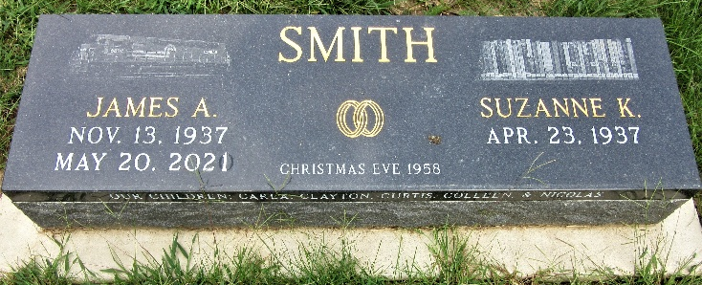
Photo by PLS

James A. Smith, 83, of Decatur, Indiana passed away Thursday, May 20, 2021, at Adams Woodcrest in Decatur. He was born on November 13, 1937 in Decatur, Indiana to the late James G. Smith and late E. Celesta (Shaffer) Smith. James was united in marriage to Suzanne Kuhn on December 24, 1958 in Willshire, Ohio. He proudly served his country as a U.S. Marine being honorably discharged on April 1, 1958.
James graduated from Pleasant Mills High School in 1955. He was a member of Common Ground Church of the Nazarene. He was employed by Pennsylvania Railroad; Penn Central; Conrail; CSX; and retired on December 3, 1999 with 44 years and 18 days of service.
He enjoyed gardening, fishing and helping out in the community. He and his wife Suzanne traveled six out of the seven continents and all 50 states.
He is survived by his loving wife, Suzanne Smith of Decatur, Indiana; daughter, Carla D. (Curtis) Alspaugh of Craigville, Indiana; son, Clayton D. (Janis) Smith of Decatur, Indiana; son, Curtis D. (Jana) Smith of Albert Lea, Minnesota; daughter, Colleen D. (Cornelius) Blanton of Bluffton, Indiana; son, Nicolas J. (Jessica) Smith of Monroe, Indiana; over a fifteen-year period James and Suzanne fostered 22 children including, Tonya J. (Matthew) Reno and unofficially adopted Curtis L. (Rhonda) Rayford; sister, Janice A. Medaugh of Decatur, Indiana; 16 grandchildren, Celeste; Claire, Clinton; Brielle, Preston; Shaletta, Jade, Jalen, Ashley, Case; Nicolas, Ethan, Chance; Braxton, Emilee and Kylee; and 11 great-grandchildren.
He was preceded in death by a brother, Jerry A. Smith; sister, Jane A. Roush; and a great-granddaughter, Sadie W. Gilbertson.
A funeral service will be held 11:00 a.m. Thursday, May 27, 2021, at Common Ground Church of the Nazarene in Decatur with Pastor Preston C. Smith officiating. Military graveside honors will be conducted by the American Legion Post #43 Color Guard at Decatur Cemetery with Pastor Joyce Kuhn officiating. Friends and family will be received from 4-8 p.m. on Wednesday, May 26, 2021, at the Zwick & Jahn Funeral Home, Decatur and one hour prior to the service at the church on Thursday.
Preferred memorials are to Common Ground Church of the Nazarene.

Zwick & Jahn Funeral Home, Adams County, Indiana
May 30, 2021

