Isaac Smith
March 27, 1842 – January 26, 1915

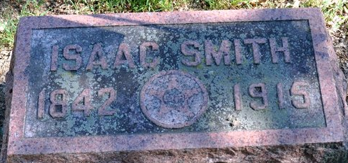
Photo by Deb Curry

THE DEATH TOLL - Isaac Smith, Aged Resident of St. Marys Township, Succumbed Today - WAS ILL LONG
Isaac Smith, about seventy-five years of age, a well-known and esteemed resident of St. Mary’s Township, living five miles east of this city near the Calvary Church, died this morning between seven and eight o’clock. He had been ailing the past year of a complication of illnesses, superinducing dropsy.
He was the son of Zachariah and Susanna Smith, and was born in St. Mary’s Township, where his life was spent. He was married in young manhood to Miss Margaret Cowan. The widow, with two daughters, are living. The children are Miss Jennie at home, and Lulu, wife of Delbert Walters, of St. Mary’s Township.
Mr. Smith is very well known in this city, being an uncle of Mrs. J.L. Gay and others. He is a brother of Joe Smith of this city, and of Mrs. Irvin Acker, of this city, Mrs. John Teeple and Mrs. Martha Frisinger of this city and county, and of Mrs. Mary Teeple of Geneva.
Mr. Smith has been a resident of the farm where his death occurred for thirty-five years and is one of the pioneer residents of the community.
Mr. Smith was a veteran of the Civil War and served well, being a member of the 89th regiment. The G.A.R. will meet this evening at 7 o’clock to make arrangements at attend the funeral which will be held Thursday. The procession will leave the residence at 1 o’clock sun time, Thursday afternoon, for the Calvary Church east of this city, where the Rev. Powell of Bobo will be in charge. Burial will take place in the Decatur Cemetery.

Decatur Democrat, Adams County, Indiana
Tuesday, January 26, 1915

**
Indiana, U.S., Death Certificates, 1899-2017
Name Isaac Smith
Gender Male
Race White
Marital Status Married
Age 72
Birth Date 27 Mar 1842
Birth Place St. Marys Township, Adams County, Indiana
Death Date 26 Jan 1915
Death Place Saint Marys, Adams, Indiana, USA
Death Registration Date 1910-1919
Father Zachariah Smith
Mother Susanna McClelen
Spouse Margaret E.
Informant Margaret E. Smith; Decatur, Indiana
Burial January 28, 1945; Decatur Cemetery

