Ida E. (Evans) Smith
October 8, 1865 – February 18, 1937

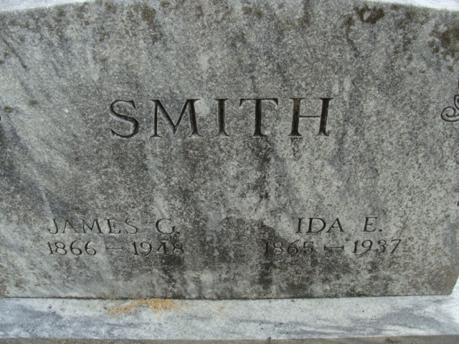
Photo by Alicia Kneuss

Ida E Smith
in the Michigan, U.S., Death Records, 1867-1952
Name Ida E Smith
[Ida E Evans]
Gender Female
Race White
Marital Status Married
Death Age 71
Birth Date 8 Oct 1865
Birth Place Fulton Co Indiana
Death Date 18 Feb 1937
Death Place Lansing, Ingham, Michigan, USA
Father Robert Evans
Mother Elizabeth Sparks
Informant James Smith; Fort Wayne, Indiana
Burial February 21, 1937; Ft. Wayne, Indiana

