Hilda N. Smith
October 7, 1909 – July 10, 1981

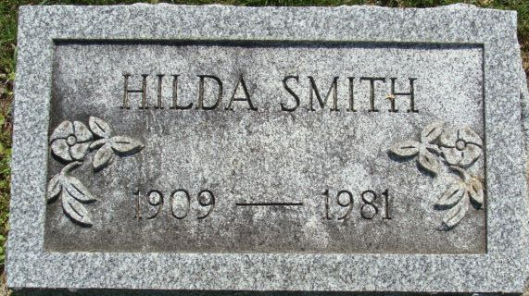
Photo by Alicia Kneuss

Hilda N. Smith
in the Indiana, U.S., Death Certificates, 1899-2017
Name Hilda N. Smith
Gender Female
Race White
Marital Status Single
Age 71
Birth Date 7 Oct 1909
Birth Place Indiana
Death Date 10 Jul 1981
Death Place Fort Wayne, Allen, Indiana, USA
Death Registration Date 1981
Father John W. Smith
Mother Sally Jane Stewart
Informant Mrs. Sybil Rasp; Decatur, Indiana
Burial July 13, 1981; Decatur Cemetery; Decatur, Indiana

