Hettie (Smith) Smith
December 26, 1847 – December 28, 1910

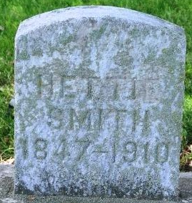
Photo by Deb Curry

Hettie Smith
in the Indiana, U.S., Death Certificates, 1899-2017
Name Hettie Smith
Gender Female
Race White
Marital Status Widowed
Age 64
Birth Date 26 Dec 1846
Birth Place Ireland
Death Date 28 Dec 1910
Death Place Decatur, Adams, Indiana, USA
Death Registration Date 1910
Father John Smith
Mother Sarrah Crewer
Spouse James Smith
Informant David Smith; Decatur, Indiana
Burial December 31, 1910; Decatur Cemetery

