Henry L. Smith
December 5, 1887 – October 13, 1967

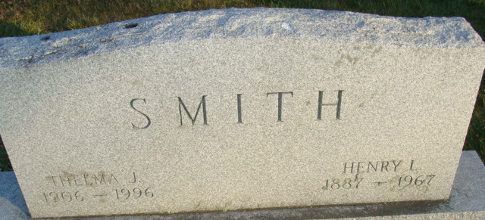
Photo by Alicia Kneuss

Henry L. Smith, 79, manager of the Credit Bureau of Defiance, who has been in failing health for some time, died at 6:15 p.m. Friday of a heart attack in his residence, 1800 Darbyshire Drive.
Mr. Smith had lived in Defiance for 21 years, having moved to this city from Sandusky.
He was born on Dec. 5, 1887 in Cleveland. His parents were Byron and Lydia (Lindebury) Smith.
Mr. Smith is survived only by his wife, the former Thelma Johnson, to whom he was married on April 23, 1936 in Angola, Ind.
He was a member of the Presbyterian Church and the Defiance Lions Club, of which he was a past president.
Services will be conducted at 1 p.m. Monday in the Rupp Funeral Home by the Rev. John O. Meloy, Presbyterian minister and burial will be in the Decatur, Ind. cemetery. Friends may call in the funeral home after 2 p.m. Sunday.

Defiance Crescent News, Defiance, Ohio
Saturday, October 14, 1967

