Harvey L. Smith
December 17, 1922 – April 2, 2011

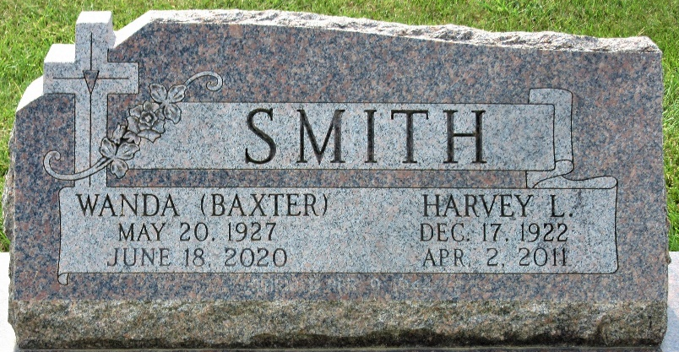
Photo by Alicia Kneuss

Harvey L. Smith, 88, of Monroe, IN went home to live in perfect health with his Heavenly Father on Saturday, April 2, 2011. Even among the sadness and loss of a wonderful man, a supportive brother, a marvelous husband, a loving, caring father, and a long-time terrific business man, the Harvey L. Smith family is celebrating the life they shared with him.
Harvey was born on December 17, 1922 to Adolph E and Alice C (Helmrich) Smith. On April 9, 1944 he married Wanda M. Baxter.
He is survived by his wife of 67 years Wanda M. Smith of Monroe, IN; children include a daughter Arvilla (husband, Thomas) Ripley of Lexington KY; son Ronald (wife, Donna) of Decatur; daughter Janet Omspach of Monroe; son Rodney (wife, Lori) of Fort Wayne and son Roger (wife, Pam) of Monroe. He also has 13 grandchildren and 19 great-grandchildren: 1 brother, John Ray Smith, of Preble and 1 sister, Florence (Mrs. Frank) Williams of Birmingham AL. He was preceded in death by 2 grandchildren and his 2 sisters Edna Smith and Barbara Smith Hand.
From 1941 through the early 1990s, Harvey was known as “the Fuller Brush man” to many. During that career he sold products door to door, trained many men and women to do likewise and spent many years as a manager. In 1973 he started working full time at the family business, Smith Trailer Sales, his wife started in 1959. Smith Trailer Sales was started behind their home and still flourishes today at the same location just outside Monroe. He continued to answer the phones into 2010 when his health no longer allowed him to do so. Harvey served many years on consistory at St John Church in Vera Cruz where he attended his entire life.
The family will receive those who would like to pay their respects on Friday, April 8, 2011 from 2:00 - 8:00 p.m. at Haggard-Sefton & Hirschy Funeral Home, 225 W. Adams Street, Decatur IN
The Funeral Service/Celebration Service of Harvey’s earthly life will be at Haggard-Sefton & Hirschy Funeral Home, 225 W. Adams Street, Decatur IN on Saturday, April 9 at 11:00 a.m. with visitation 1 hour prior to the service.
Memorials may be given, if desired, to Family Hospice & Palliative Care of N.E. Indiana or to an organization of the donor’s choice. Burial will be in the Decatur Cemetery.

Haggard-Sefton & Hirschy Funeral Home, Adams County, Indiana
April 3, 2011
**
Indiana, U.S., Death Certificates, 1899-2017

Name Harvey L Smith
Gender Male
Race White
Age 88
Marital Status Married
Birth Date 17 Dec 1922
Birth Place Adams County, Indiana
Death Date 2 Apr 2011
Death Place Monroe, Adams, Indiana, USA
Death Registration Date 2011
Father Adolph E Smith
Mother Alice C Helmrich
Spouse Wanda M Baxter Smith, informant
Burial Decatur Cemetery, no date listed

