Harve L. Smith
August 13, 1862 – May 9, 1944

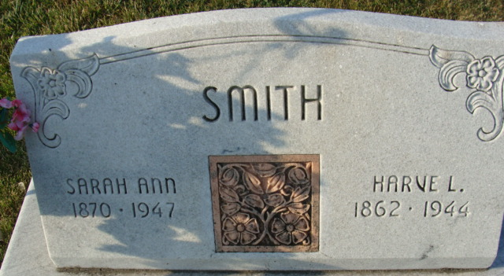
Photo by Alicia Kneuss

Harvey Smith Dies Early Last Night - Funeral Services Friday Afternoon
Harvey L. Smith, 81, retired farmer, died at 7:30 o'clock Tuesday night at his home four and one-half miles southeast of Decatur. Death was caused by complications following an extended illness.
He was born in Wayne County, O., August 13, 1862, the son of Joseph and Sarah Palmer-Smith. He had resided in Adams County for 47 years.
Surviving is the widow, Sarah; five sons, Ray Smith of Decatur, Perry of Fort Wayne, Bert of Berne, Harry, residing in California and Dee, of Ligonier; two daughters, Mrs. Florence Johnston of Chicago, and Mrs. Osie Durr, at home; 12 grandchildren and five great-grandchildren. Two brothers and five sisters preceded him in death.
Funeral services will be held at 1:30 p.m. Friday at the home and 2 o'clock at St. Paul's church, with Rev. L. A. Middaugh officiating. Burial will be in the Decatur Cemetery. The body will be removed from the Black Funeral Home to the residence this evening.

Decatur Daily Democrat, Adams County, Indiana
Wednesday, May 10, 1944

