Harry Donald Smith
June 14, 1916 – March 17, 1983

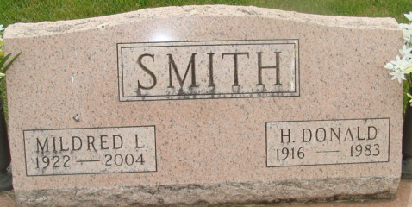
Photo by Alicia Kneuss

Harry Don Smith
in the Indiana, U.S., Death Certificates, 1899-2017
Name Harry Don Smith
Gender Male
Race White
Marital Status Married
Age 66
Birth Date 14 Jun 1916
Birth Place Indiana
Death Date 17 Mar 1983
Death Place Fort Wayne, Allen, Indiana, USA
Death Registration Date 1983
Father Harry C. Smith
Mother Ferm McClintock
Spouse Mildred Clark
Informant Mrs. Don Smith; Decatur, Indiana
Burial March 19, 1983; Decatur Cemetery; Decatur, Indiana

