Harry A. Smith
February 1, 1898 – September 10, 1970

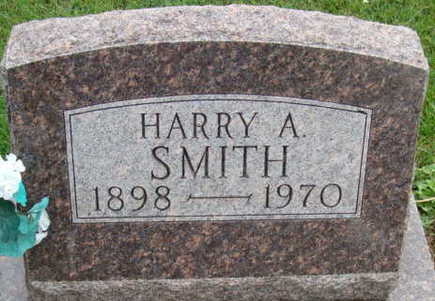
Photo by Alicia Kneuss

Harry Smith, 72, dies in L.A.
Harry A. Smith, 72, brother of local residents, passed away Thursday evening. He had been a patient of California Hospital in Los Angeles for six weeks. The deceased was born in Adams County, the third son of Harvey L. and Sarah Roe Smith, February 1, 1898.
He was an accomplished automatic screw machinist. He formed his own factory in Chicago and later moved it to Los Angeles where it was known as the Harry Smith Co. During World War 11 he was honored by the government for making outstanding parts for airplanes and received the Navy E award. He was at present producing parts for jet aviation.
The deceased is survived by his wife, Irene and one daughter, Mrs. David (Ann) Fegan, also three grandchildren, Kathryn, Mark and Brian. Four brothers survive, Ray Smith of Decatur, Perry and Bert Smith of Fort Wayne, and Dee Smith of Ligonier, and two sisters, Mrs. Ivan (Florence) Johnston of Bloomington, Illinois, and Mrs. Osie Durr, of Decatur.
The body will be returned to the Winteregg-Linn Funeral Home.

Decatur Daily Democrat, Adams County, Indiana
Friday, Sept. 11, 1970

