Harold O. Smith
July 15, 1901 – September 23, 1969

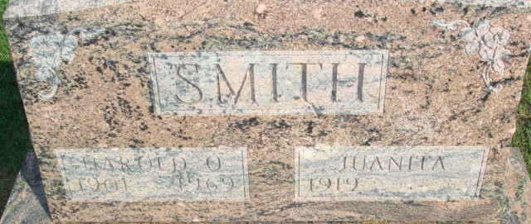
Photo by Alicia Kneuss

Decatur Native, 68, Dies in Fort Wayne

Services for Harold O. Smith, 68, of Fort Wayne, Decatur native who died at 11:30 p.m. Tuesday at the St. Joseph's Hospital will be at 1 p.m. Saturday in the D.O. McComb & Sons Funeral Home, the Rev. LaVerne Ervin officiating.
Smith had been a hospital patient for five weeks. The son of Daniel Elmer and Lydia Shraluka Smith, he was born in Decatur July 15, 1901. He has resided in Fort Wayne for the past 40 years and was retired.
Surviving is his wife, Juanita; two brothers, Richard C. Marysville, Calif., and Dale N. Wolcottville. Burial will be in the Decatur Cemetery.

Decatur Daily Democrat, Adams County, Indiana
Thursday, September 25, 1969
**
Indiana, U.S., Death Certificates, 1899-2017
Name Harold O Smith
Gender Male
Race White
Marital Status Married
Age 68
Birth Date 15 Jul 1901
Birth Place Indiana
Death Date 23 Sep 1969
Death Place Fort Wayne, Allen, Indiana, USA
Death Registration Date 1969
Father Elmer Smith
Mother Lydia Schrulaka
Spouse Juanita
Informant Juanita Smith; wife; Fort Wayne, Indiana
Burial September 27, 1969; Decatur Cemetery; Decatur, Indiana

