Gretchen Ann Smith
October 2, 1905 – October 11, 1945

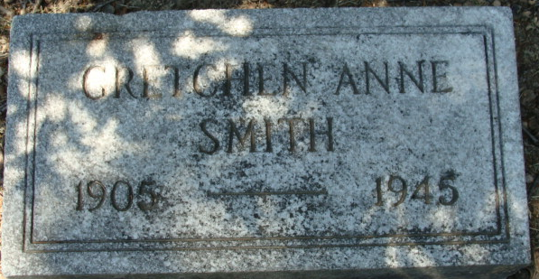
Photo by Alicia Kneuss

Gretchen Smith
in the Illinois, U.S., Deaths and Stillbirths Index, 1916-1947
Text Only

Name Gretchen Smith
Birth Date 2 Oct 1905
Birth Place Decatur, Indiana
Death Date 9 Oct 1945
Death Place Chicago, Cook, Illinois
Burial Date 11 Oct 1945
Burial Place Decatur, Adams, Ind.
Cemetery Name Maplewood
Death Age 40
Occupation Teacher of Nursing
Race White
Marital Status S
Gender Female
Street Address 1828 Kenmore
Residence Gross Point Woods, Michigan
Father Name David E. Smith
Father Birth Place Ceylon, Ohio
Mother Name Hake Buffington
Mother Birth Place Decatur, Indiana
FHL Film Number 1983370

**

Gretchen Ann Smith from Larson Family Tree
Father David Edward Smith
Mother Ethel Hale
Birth 2 Oct 1905 Decatur, Adams, Indiana, USA
Death 9 Oct 1945 Chicago, Cook, Illinois, USA
Residence 1921 Fort Wayne, Allen, Indiana, USA

