Grace M. (Zerkel) Smith
June 17, 1892 – April 2, 1975

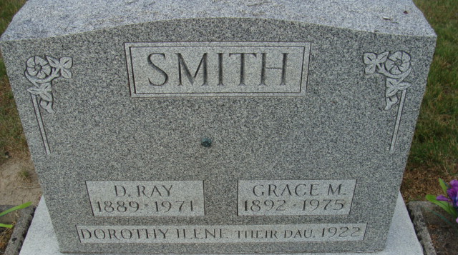
Photo by Alicia Kneuss

Mrs. Grace M. Smith, 82, of Route 6, widow of Daniel Ray Smith, died at 11 a.m. Wednesday at the Adams County memorial hospital, following an extended illness.
A lifelong resident of Adams County, Mrs. Smith was a member of St. Paul's Missionary Church.
Born in Kirkland Township on June 17, 1892, she was a daughter of Jacob A. and Oceano Bell-Zerkel, and was married on July 27, 1910 to Daniel Ray Smith who died Oct 18, 1971.
Survivors include two sons, Clarence E. (John) Smith of Decatur; Lawrence R. (Pete) Smith of Decatur; one daughter, Mrs. Austin (Ruth) Merriman of Route 1, Monroe; eight grandchildren; 19 great-grandchildren and two great-great-grandchildren. One daughter, Dorothy, four sisters and four brothers preceded her in death.
Funeral services will be held Saturday at 2 p.m. at the Winteregg-Linn & Haggard funeral home, with Rev. Robert Welch officiating. Burial will be in Decatur cemetery. Friends may call at the funeral home after 12 noon Friday.
Preferred memorials are to the American Cancer Society.

Haggard & Sefton Funeral Home, Adams County, Indiana
April 3, 1975
**
Indiana, U.S., Death Certificates, 1899-2017

Name Grace M. Smith
[Grace M. Zerkel]
Gender Female
Race White
Marital Status Widowed
Age 82
Birth Date 17 Jun 1892
Birth Place Indiana
Death Date 2 Apr 1975
Death Place Decatur, Adams, Indiana, USA
Death Registration Date 1975
Father Jacob A. Zerkel
Mother Oceano Bell
Informant Clarence E. Smith; son; Decatur, Indiana
Burial April 5, 1975; Decatur Cemetery; Decatur, Indiana

