Goldie A. (Gay) Smith
March 20, 1885 – January 1, 1959

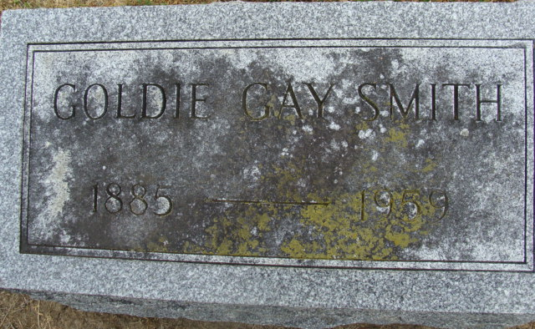
Photo by Alicia Kneuss

Mrs. Goldie Smith Dies Last Evening
Native of Decatur Dies in Michigan

Mrs. Goldie A. Gay Smith, 73, a native and former well-known resident of Decatur, died Thursday night at a hospital in Alma, Mich., following a serious illness of two weeks.
Mrs. Smith, a member of a prominent Decatur family, served as deputy Adams County treasurer for many years before she and her husband, Elwin Smith, moved to Alma.
She was born in Decatur March 20, 1885, a daughter of James L. and Martha E. Teeple-Gay.
Mrs. Smith was a member of the First Methodist Church at Alma and was a member of the Order of Eastern Star and the Rebekah lodge of Decatur.
Surviving are three brothers, J. Fred Gay of Ithica, Mich., Richard D. Gay of Alma, Mich., and William B. Gay of Stanton, Mich., one sister, Mrs. Omer (Ruth) Parent of Clara, Mich.
Funeral services will be held at 2 o'clock Sunday afternoon at the Dewey Funeral Home in Alma. The body will then be brought to the Zwick Funeral Home in this city for services at 1:30 p.m. Monday, the Rev. Charles Hahn of Alma officiating. Burial will be in the Decatur Cemetery.

Decatur Democrat, Adams County, Indiana
Friday, January 2, 1959

