Gerald Verlin Smith
October 17, 1922 – October 9, 2009

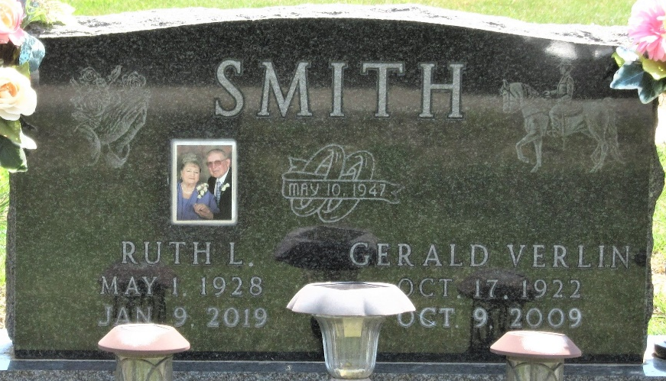
Photo by PLS

Gerald Verlin Smith, 86, of Monroeville, passed away Friday, Oct. 9, 2009, at his residence. Born Oct. 17, 1922 in Bluffton, he was the son of Maynard and Mary Jane (Lash) Smith. He married Ruth L. Hess 62 years ago, on May 10, 1947, she survives in Monroeville.
He retired in 1987 from B.F. Goodrich after 25 years of service. He then drove truck for 15 years for R.J. Becher & Sons in Berne, owned by his son-in-law Ron Becher.
Gerald was a proud WWII veteran having served in the South Pacific on the Palau Islands. Two years ago, his family took him to the WWII Monument in Washington D.C., where people stood in line to shake his hand, take pictures, and thank him for his service.
He loved his family above all else and he always loved and cared for animals, especially horses, goats, dogs and cats. He was always emphatic that in place of flowers, he wanted bags of dog feed around his casket.
He is also survived by two sons, Gary (Janet) Smith of Decatur, and Dean (Julia) Smith of Monroeville; three daughters, Shirley (Ray) Scott of Hoagland, Diane (Larry) Irwin of Decatur, and Julie (Ron) Becher of Berne; nine grandchildren, Jamie Horne of Fort Wayne, Eric (Stacey) Smith of Monroe, Landon Smith and Nick (Lindsey) Irwin both of Decatur, Ryan (Holly) Becher and Cole (Cassie) Becher both of Berne, Josh (Kary) Smith of New Haven, Alisa Irwin and Melissa (Thomas) McCullough both of Decatur; nine great- grandchildren, Paige Horne, R.J. and Ian Smith, Corbin, Ivy, Talon, Duncan, Jackson and Mavrick Becher. Baby Smith and Baby McCullough are due in 2009; two half brothers, William (Marge) Simon of Berne, and Tom E. (Velma) Smith of Frankfort, Ind.; sister-in-law, Rosanna Simon of Berne; brother-in-law, Robert Evans of Forest, Ind. He was also a "grandfather" to Marcus Miller of Decatur. He was preceded in death by Matthew Miller on August 12, 2009, (who was like a grandson to him); brother, Harold Smith; sister, Mabeline Moser; half brother, Roger Simon; half sister, Judy Evans; two stepbrothers, Victor and James Simon; two stepsisters, Martha Gifford and Leola Sprunger.
Funeral Service is 11 a.m. Wednesday at Haggard & Sefton Funeral Home with Rev Ralph Klinker officiating. Visitation from 2 to 8 p.m. Tuesday at the funeral home. Burial in Decatur Cemetery with Military Graveside Rites by the American Legion Post 43.
Memorials to Monroeville EMS or ACSPCA (Allen County Society for the Prevention of Cruelty to Animals).

Haggard & Sefton Funeral Home, Adams County, Indiana
October 10, 2009

