Gerald P. Smith
November 13, 1907 – October 11, 1989

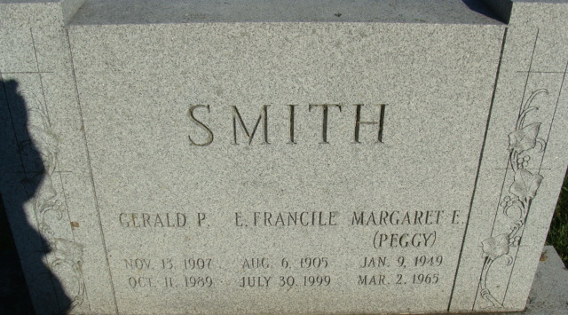
Photo by Alicia Kneuss

Gerald P Smith
in the Indiana, U.S., Death Certificates, 1899-2017
Name Gerald P Smith
Gender Male
Race White
Marital Status Married
Age 81
Birth Date 13 Nov 1907
Birth Place Decatur, Indiana
Death Date 11 Oct 1989
Death Place Decatur, Adams, Indiana, USA
Death Registration Date 1989
Father Joseph S Smith
Mother Margaret L Kintz
Spouse E. Francile Lower
Informant Mrs. E. Francile Smith; wife; Decatur, Indiana
Burial October 14, 1989; Decatur Cemetery; Decatur, Indiana

