George A. Smith
November 23, 1929 – July 31, 2001

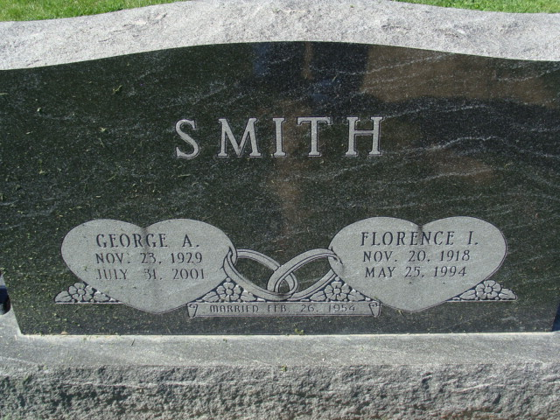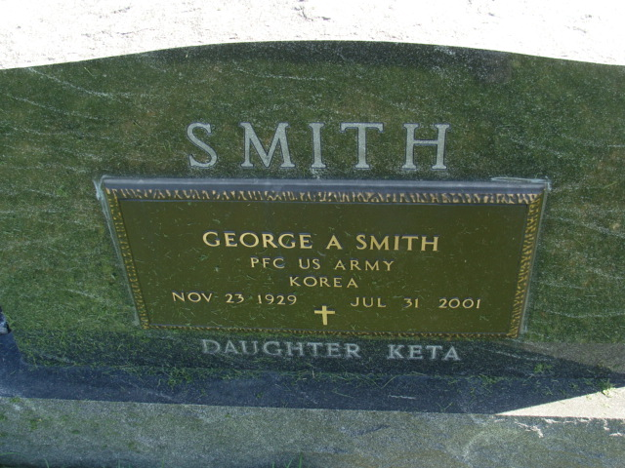
Photos by Alicia Kneuss

Decatur - GEORGE A. SMITH JR., 71, died Tuesday at St. Joseph Hospital, Fort Wayne. Born in New Orleans, he worked at Reidenbach Equipment since 1962. He was a Korean War Army veteran .. His first wife, Florence, died in 1994. Surviving are his wife, Cynthia (2nd husband); a daughter, Keta M. Bender of New Almond of Alexandria, Va.; two sisters, Lorraine Hymal of Natalbany, La., and Carolyn Reith of Gretna, La.; two step-sons, Randall Hileman of Oaklawn, Ill., and Curt Hileman of Willshire, Ohio; a stepdaughter, Julie Gavin of Decatur; and three grandchildren. Services at 11 a.m. Saturday at Zion Lutheran Church, Decatur, with calling one hour before services. Calling also from 1 to 9 p.m. Friday at Zwick & Jahn Funeral Home, Decatur. Burial in Decatur Cemetery, with military graveside honors by American Legion Post 43, Decatur. Memorials to Adams County Heart Club or the church.

Berne (IN) Library Heritage Room
Misc obits
Handwritten-July 31, 2001

