Fred Rice Smith
August 29, 1889 – January 23, 1970

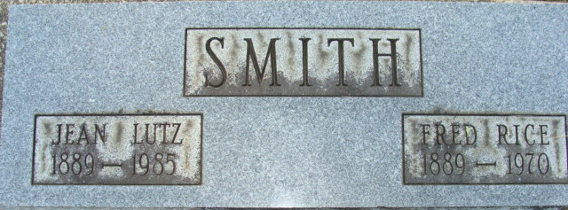
Photo by Alicia Kneuss

Fred R. Smith Dies After Long Illness

Fred R. Smith, 80, of 318 South Third Street, well known retired businessman, died at 3:27 p.m. Friday at the Adams County Memorial Hospital following an extended illness.
A lifelong resident of the community, he was born in Adams County Aug. 29, 1889, to William R. and Nancy J. Rice-Smith, and was married to Jean B. Lutz May 6, 1915.
Mr. Smith was a member of the Presbyterian Church, which he had served as an elder and a member of Decatur lodge 571, F & AM, and the Scottish Rite. He retired a number of years ago after being associated in business with a son.
Surviving is his wife; two sons, Clark W. Smith and Lewis L. Smith, both of Decatur route 4; two sisters, Mrs. Kathryn Lachnit of Indianapolis, and Mrs. Don K. (Irene) Vancil of Cincinnati, O., one brother, Robert J. Smith of Indianapolis; five grandchildren and one great-grandchild. One son, Frederick, one sister and five brothers are deceased.
Funeral rites will be conducted at 2 p.m. Monday at the Winteregg-Linn Funeral Home, with Rev. Robert Vander Hart officiating. Burial will be in the Decatur Cemetery. Friends may call at the funeral home after 7 p.m. today until time of the services.
Preferred memorials are to be to the Presbyterian Church building fund or the American Cancer Society.

Decatur Daily Democrat, Adams County, Indiana
Saturday, January 24, 1970

